Risk Analysis and Default Prediction for Taiwan Companies

Milestone III Report

Team Member: Yuan-Hsi Lai, Pei-Ling Tsai

Current Status

In milestone II (The green bubbles in ***Figure1.***), we used sentiment analysis to give scores to posts retrieved from news and social media. These scores represent how confident the public is to the company. In this stage, we focus on forming a vector used for training. Thus, we combine the financial vector, sentiment factor in news and social media together. Then we used stock value with debt-to-equity ratio to form a training label for each company. After that, we used LSTM model, a kind of recurrent neural network, to train data.

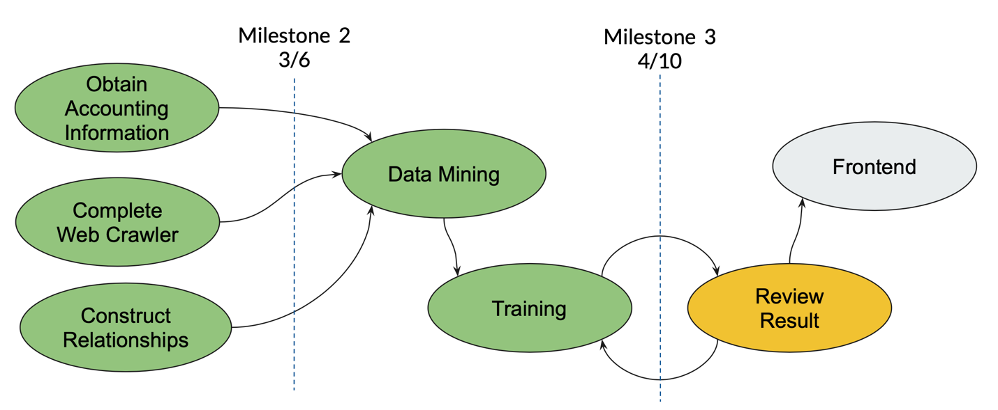

Figure

**Accounting Data**

As mentioned in the previous report, we used nine financial ratios to form a vector. Then we used JSON format to save company name with its vector into a file (***Figure 2***.). Each JSON file means all the vectors in one quarter.

root@d5f90a8e4750:~/work/Documents/Big_Data_Class/project/fin_data# ls ratios*

ratios2018Q4.json ratios2019Q1.json ratios2019Q2.json ratios2019Q3.json ratios2019Q4.json

root@d5f90a8e4750:~/work/Documents/Big_Data_Class/project/fin_data#

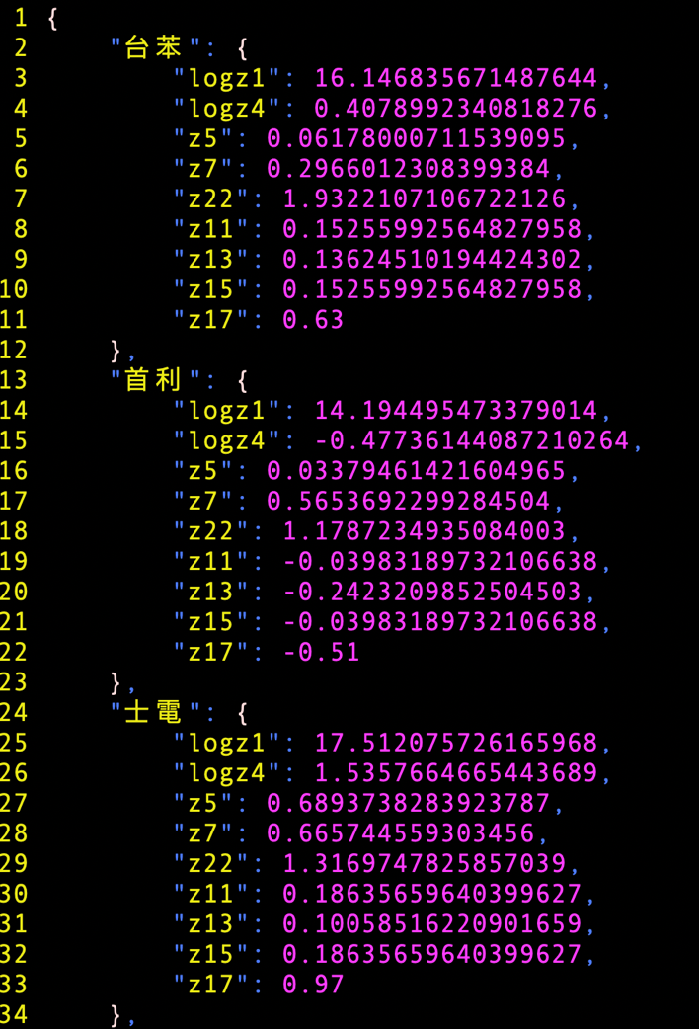

Figure 2

**News and PTT Posts**

Modifications in the news crawler:

1. searching range: We changed 14 days of searching range to one quarter (3 months). To comply with the financial statements.
2. Adding filter: For some small companies that are not famous, the Google search engine would fill in unrelated articles to the search result, especially when the date is far from now. Thus, we used the filter to eliminate those articles. Although it would make the result list to be empty sometimes, it can prevent those unrelated articles from affecting the sentiment score.
3. Saving by quarter: To comply with the financial statements, we also put results into files by quarter.

Changed from Twitter to PTT:

Since only premium members of Twitter can get posts over 7 days, we decided to change the social media to PTT (one of the largest social media in Taiwan).

About the PTT crawler:

(TBD)

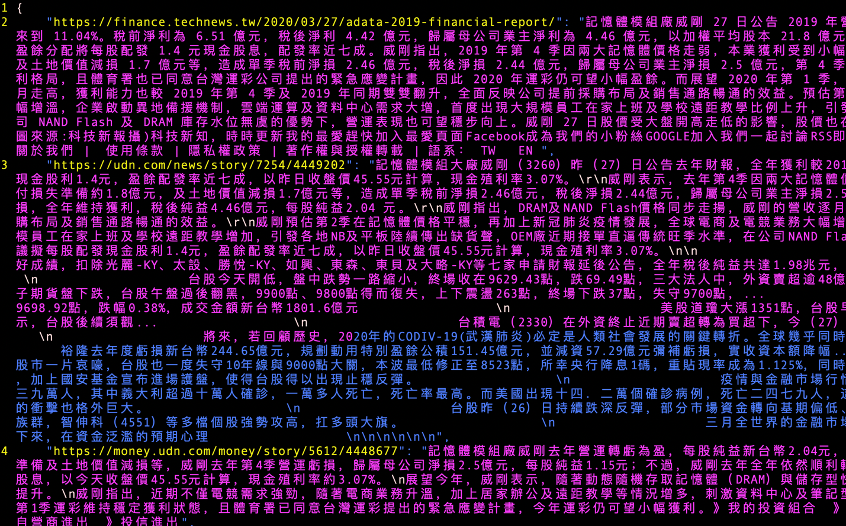

Figure 3

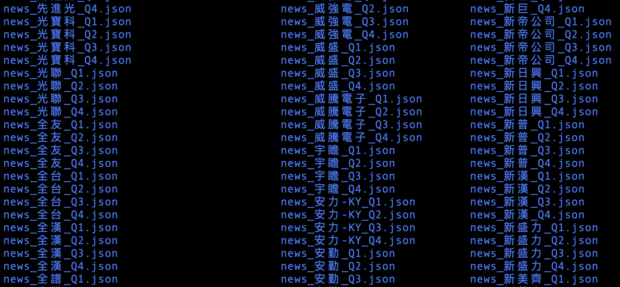

Figure 4

**Relationship between Companies** . (TBD: Move to “Next Step”)

After building the graph database of company relationship, we transferred the “distance” between companies into a numberThis number will join the final vector later.

**Improvement of Sentiment Analysis**

In the previous stage, we found that the accuracy of sentiment analysis didn’t do well. Thus, we improved by using the following methods:

1. …(TBD)

**Output labels**

We need labels to tell us how “good” the model is. Thus, we used some accountable information to help us. We put stock value and debt-to-equity ratio together, giving them equal weights. The reason why we used these two values is: the stock value is how investors think about this company and the debt-to-equity ratio is a straightforward number about how good the company can pay the money back.

**LSTM model**

* Why do we choose this model?

LSTM model is a kind of recurrent neural network, which will “remember” the history information. Since we have data from different periods, the LSTM model will help us dispatch weights to different times, for example, it would keep the information from long-term data though it might give it smaller weights.

* Input shape

The LSTM model required 3-dimention input. Thus, the format is: (sample, timestep, factors)

1. sample: companies
2. timestep: quarters (we set two timesteps, half year, in the model)
3. factors: the final vector containing all numbers we care

* Data

Training 🡪 Data from 2019Q1 & 2019Q2

Testing 🡪 Data from 2019Q3 & 2019Q4

* Configuration

1. Setting “Dropout = 0.1” to avoid overfitting
2. Using ReLU (Rectified Linear Unit) as the activation function
3. Use MSE as the loss function
4. Setting “epochs=10” for backpropagation

* Final Result

Please refer to ***Figure5.***, the model accuracy is about 90% (the range is around 86% ~ 90%, since the “Dropout” function randomly chooses samples to drop). Since the performance of model is good, we will use this model to do the default prediction.

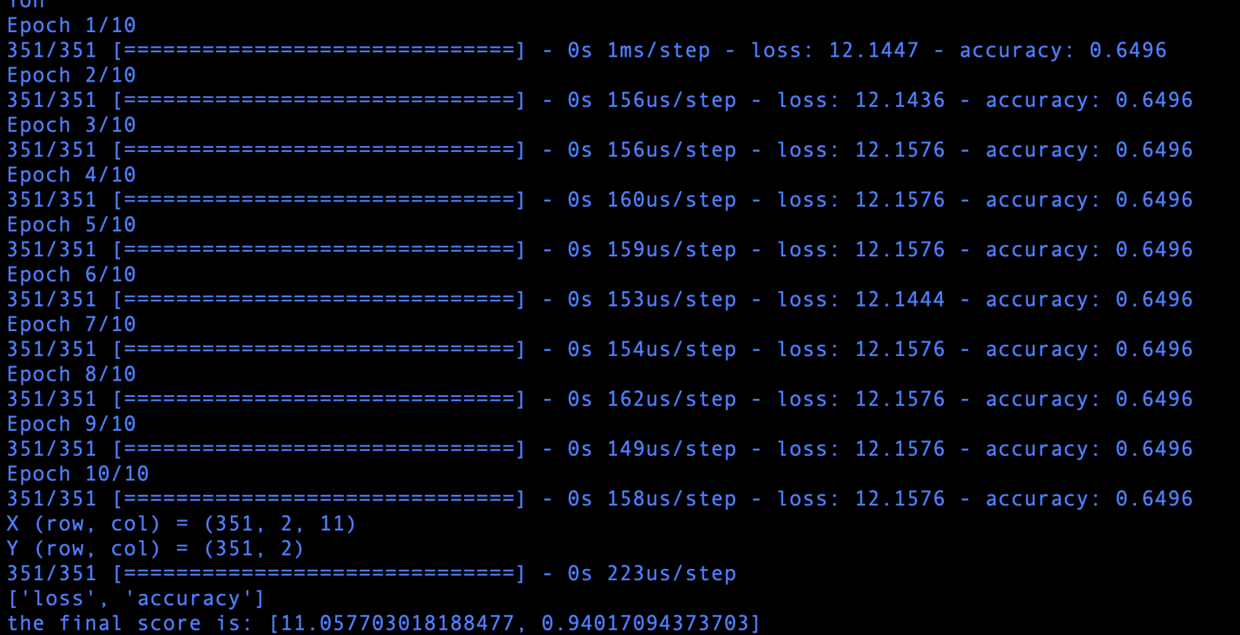

Figure

Challenges & Solutions (TBD)

**Cannot find financial statements of foreign companies**

Since the “Market Observation Post System” only provide domestic companies’ financial statements, we cannot count financial ratios for foreign companies. Thus, for the input data, we padded zero vector inside; for the output label, we simply put “3.0” as the output. The reason we chose “3.0” is because we set “threshold=3.0” in ReLU activation function and the number can help us minimize the loss function.

**Choosing an appropriate activation function**

There are many activation functions, such as “Sigmoid”, “Tanh” and “linear”. What we want to present to users is the “confident” of a company. Thus, we want to categories those outputs into “good”, “neutral” and “bad”. After try several activation functions, we found “ReLu” best fit out model.

Next Steps (TBD)

* Add more global industry information into the input vector: We will take the relationship between companies and products into consideration. For example, there are many companies produce memory. If the demand of memory is high, it would have positive impact on those manufacturers.
* Collecting 2019 Q1 data: After training the model, we will use this model to do the default prediction.
* UI design: After having the prediction, we will design a user interface to let investors know the prediction for each company.

References

*1. “Credit Rating Change Modeling Using News and Financial Ratios”: <https://www.researchgate.net/publication/262323524_Credit_Rating_Change_Modeling_Using_News_and_Financial_Ratios>

*2. Under LSTM Networks: <https://colah.github.io/posts/2015-08-Understanding-LSTMs/>

Appendix I. Coding Part

1. news crawler (updated)

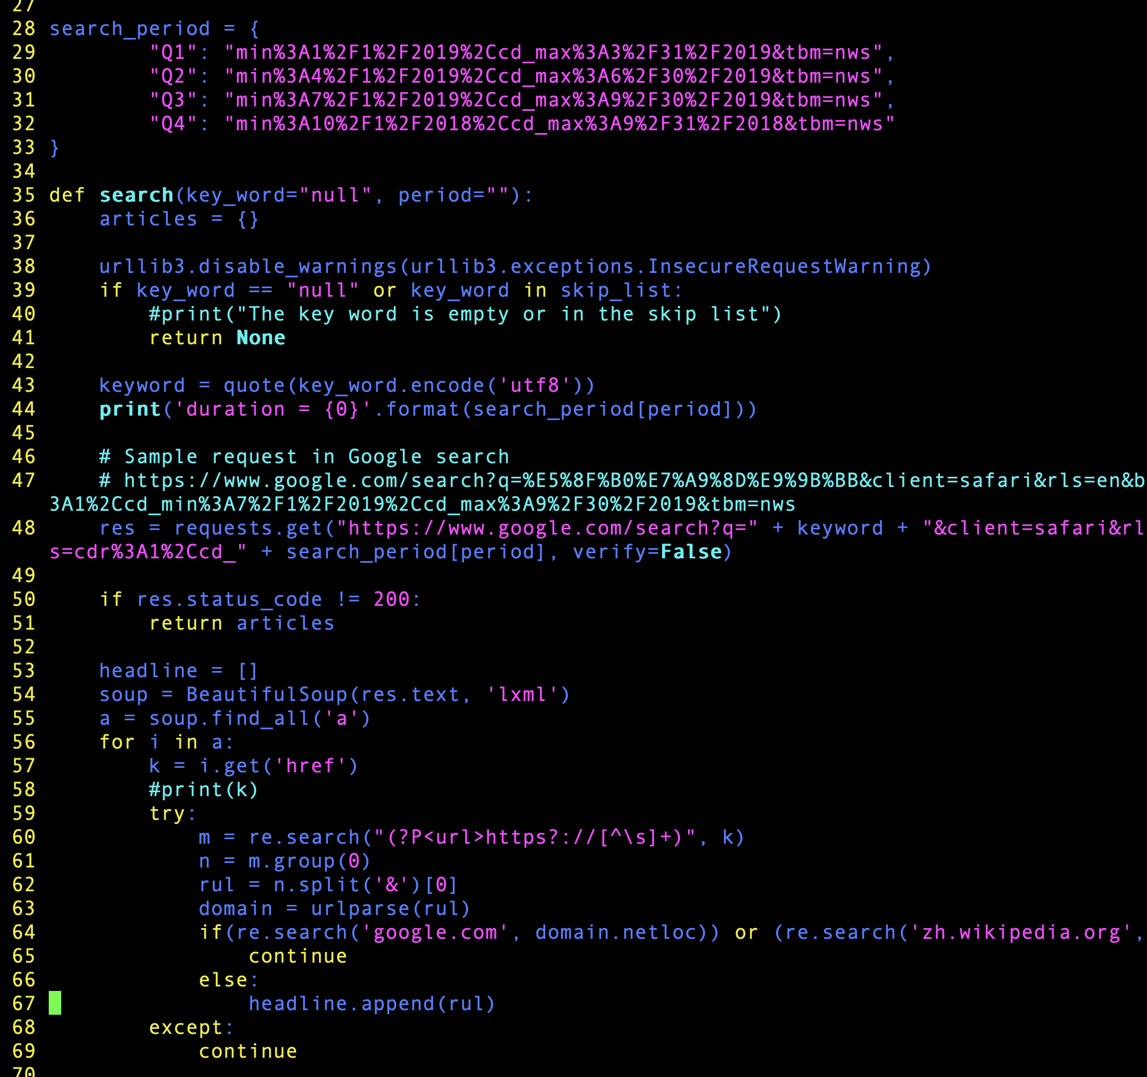

1. PTT crawler

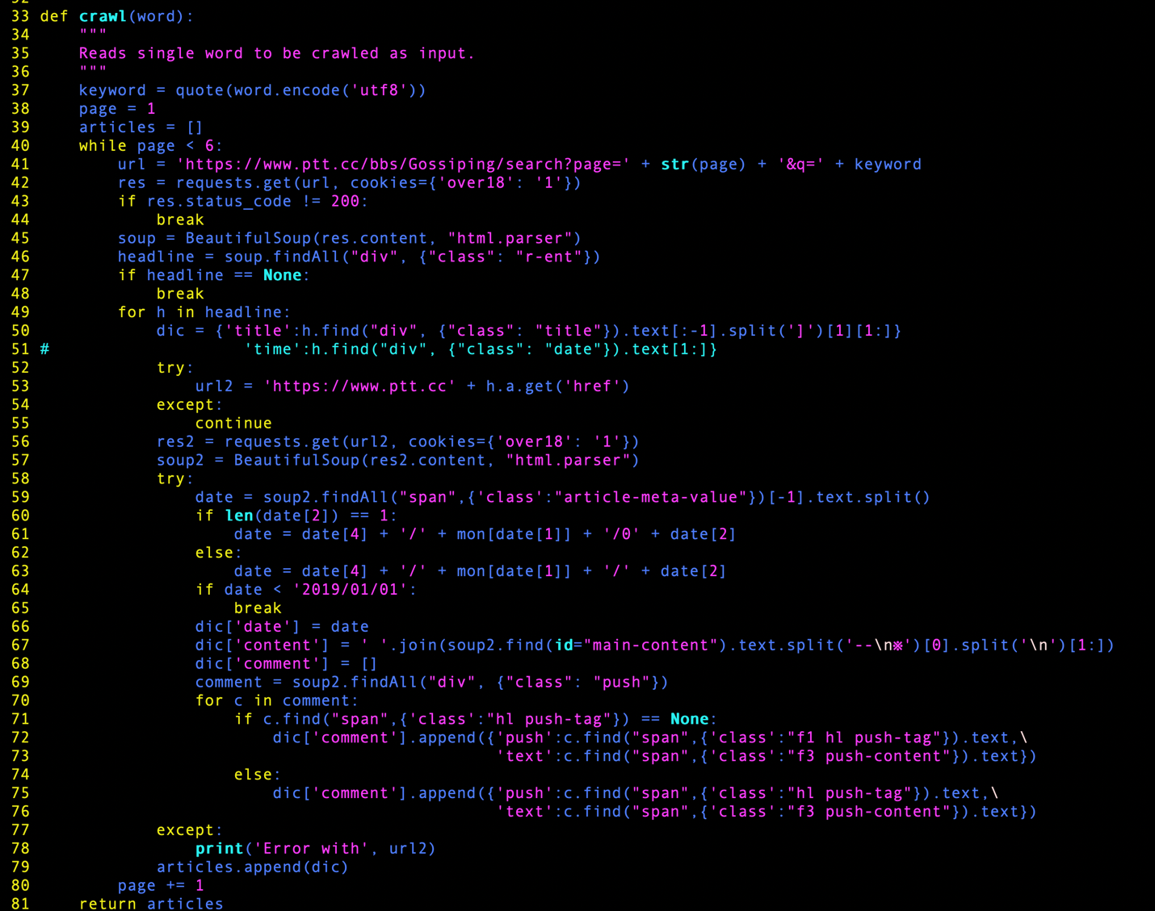

1. Creating sentiment scores

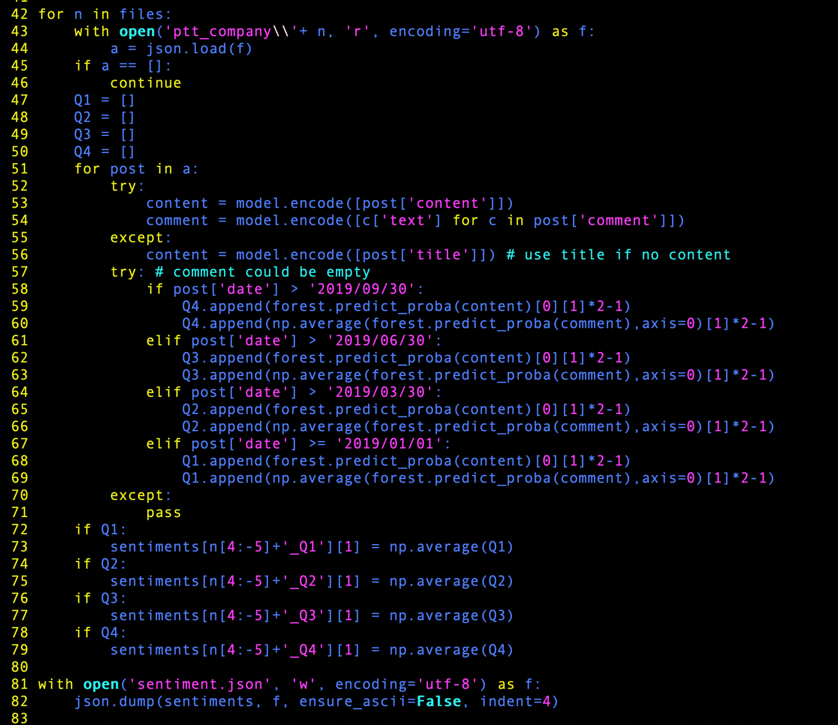

1. Creating output labels

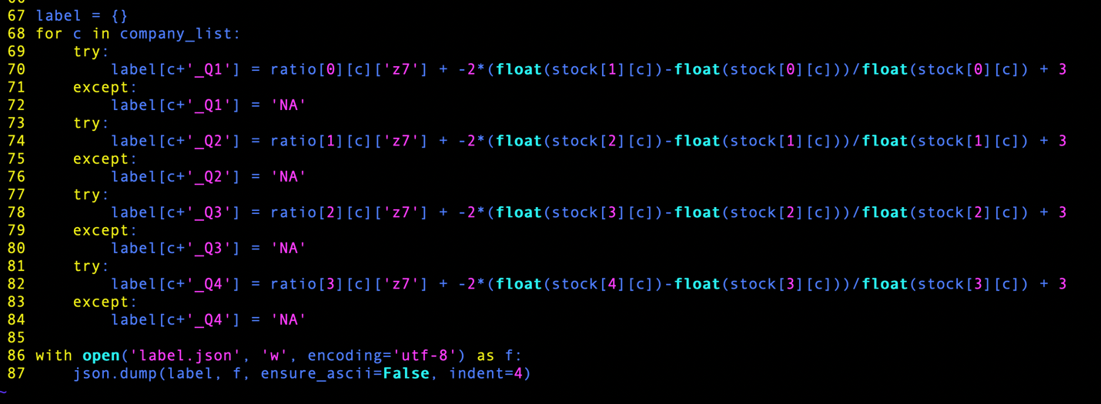

1. Creating LSTM model
2. Loading data

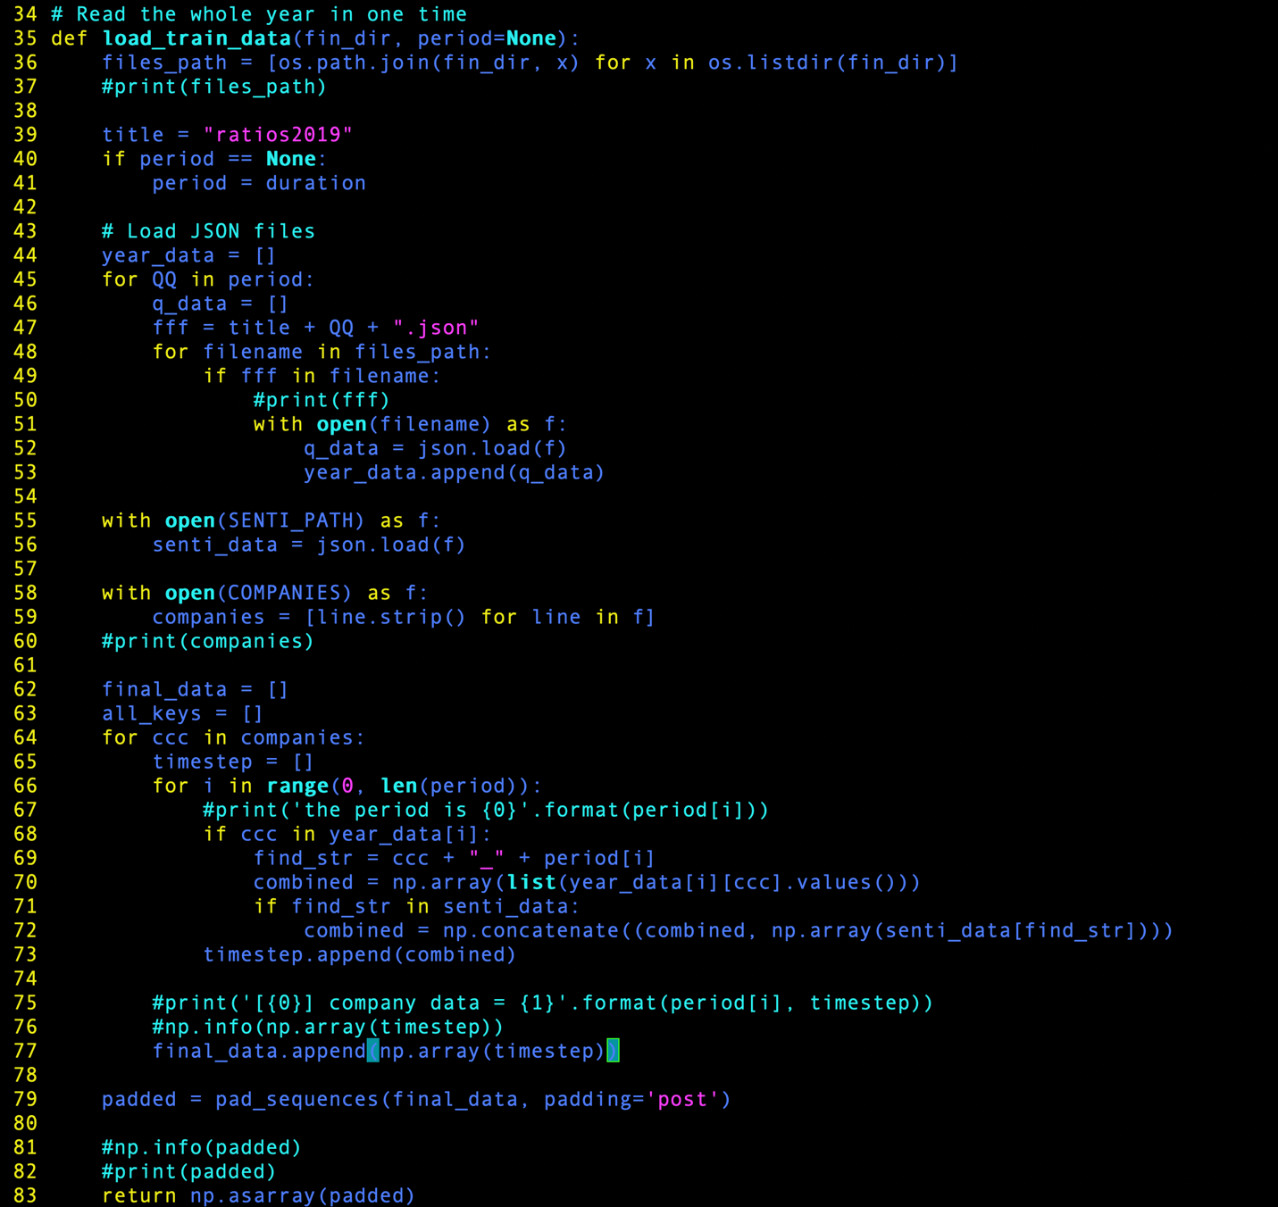

1. Training the model

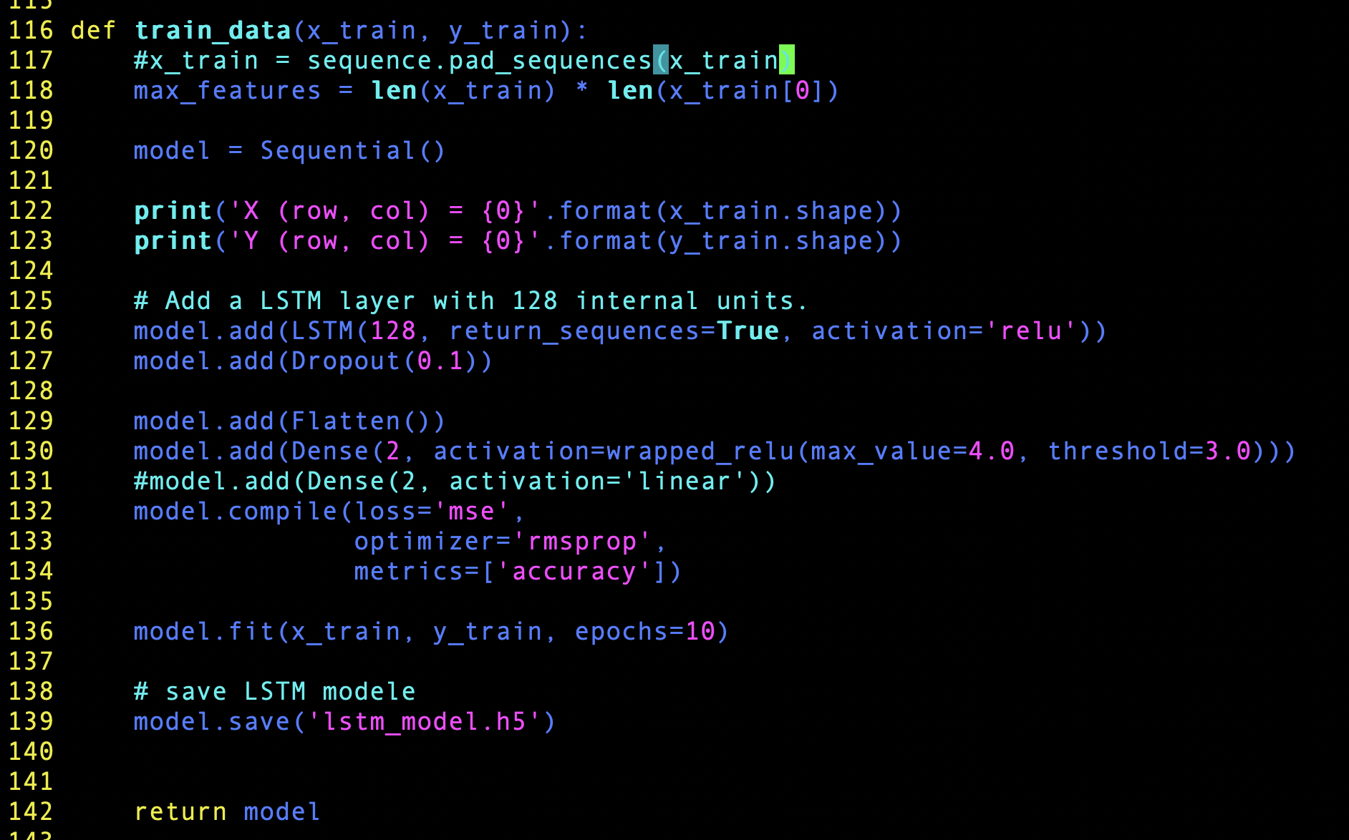

1. Evaluating the model

